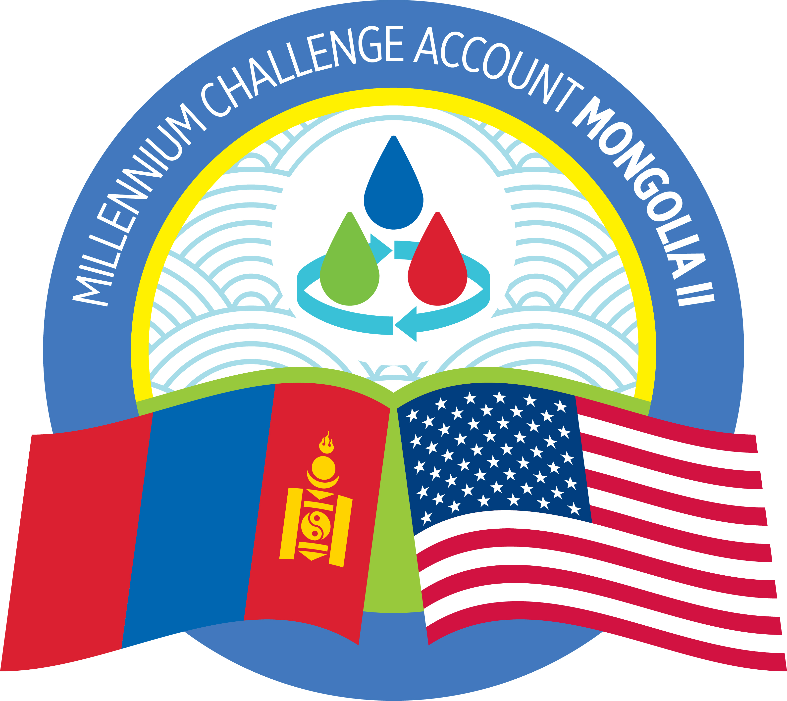
MILLENNIUM CHALLENGE ACCOUNT-MONGOLIA

NOTIFICATION OF THE REJECTION OF ALL QUALIFICATION INFORMATION
AND
ANNULMENT OF THE PROCUREMENT

Re: Consulting Services for Provision of Business English Training for MCA-Mongolia Staff
Procurement ID: MCA-M/Proc/049

Ulaanbaatar, Mongolia
February 17, 2023
To All Consultants on Record:

With reference to the above-mentioned Procurement which had a submission deadline of Qualification Information at 2 pm Ulaanbaatar time on January 09, 2023:

MCA-Mongolia has completed its evaluation of submitted Qualification Information in strict accordance with Sections 5 and 6 (Evaluation of Qualification) of the Request for Qualification Information document, and this process did not yield any successful consultant to advance to the Request for Combined Technical and Financial Proposal.

Therefore, MCA-Mongolia informs all consultants on record that it formally annuls the procurement process in accordance with Sub-Section P1.B.2.25 of the Program Procurement Guidelines (MCC Program Procurement Guidelines available at MCC website www.mcc.gov).

Procurement Agent for Millennium Challenge Account-Mongolia
Charles Kendall and Partners

